**Heuristic Evaluation Report**

Date: 11/15/19

Prepared By (team member names): Bariso Sora

***Evaluation***

Name of website being evaluated: BoxBook

Describe the scenario you used to focus your evaluation:

I want to capture events, so I can track my activities and review how I am performing.

**Problem #1**

On the event page, even though we know reserved or schedule time, it seems lacks a sign that highlights a specific date or day for which event we are viewing.

Insert print screen, location of problem:

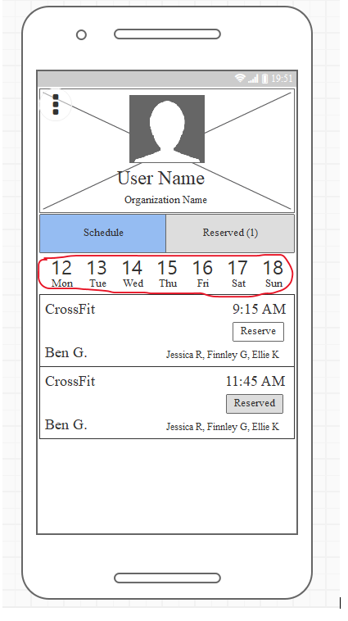

Name of heuristic: #1: Visibility of system status

Reason for reporting negative or positive: negative

Scope of problem: event page

Severity of problem (high/medium/low): low

Justification for severity rating: Users may not understand which date or day events they are viewing.

Suggestions to fix: Consider adding color that highlights the date or day when the user clicks on the event.

Possible trade-offs (why fix might not work): Some Users may not like color

**Problem #2**

It seems like the Meatball Menu page font is bigger than all other fonts.

Insert print screen, location of problem:

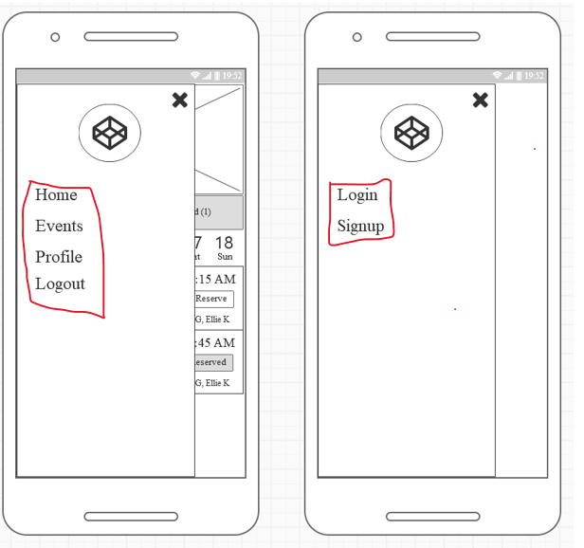

Name of heuristic: #4: Consistency and standards

Reason for reporting negative or positive: negative

Scope of problem: Meatball Menu

Severity of problem (high/medium/low): low

Justification for severity rating:  Different font sizes might distractive for users.

Suggestions to fix: Use consistent font across a web page.

Possible trade-offs (why fix might not work): Some users might like a large font.